***Project Documentation***

***CookBook: Your Virtual Kitchen Assistant***

***1. Introduction***

***Project Title:***  ***CookBook: Your Virtual Kitchen Assistant***

*•* ***Team ID:*** *NM2025TMID30946*

***• Team Leader:*** *Berlin Kiruba D*

*Email ID:*

*berlinkiruba99@gmail.com*

***• Team Members:***

***Team member :*** *BHAVYA K Email ID: bhavyasathya7@gmail.com*

***Team member :*** *DHARANI DEVI M Email ID: dharanidevi1512@gmail.com*

***Team member :*** *DHARSHINI M Email ID: Kavithadharshini759@gmail*

***Team member :*** *ELAKKIYA Email ID: saisiva531980@gmail.com*

***2. Project Overview***

*• Purpose: SB Works connects clients and freelancers through project postings, bidding, and real-time communication.*

***• Features:***

*– Project posting and bidding*

*– Secure chat system*

*– Feedback and review system*

*– Admin control panel*

***3. Architecture***

*• Frontend: React.js with Bootstrap and Material UI*

*• Backend: Node.js and Express.js managing server logic and API endpoints*

*• Database: MongoDB stores user data, project information, applications, and chat messages*

***4. Setup Instructions***

***• Prerequisites:***

*– Node.js*

*– MongoDB*

*– Git – React.js*

*– Express.js*

*– Mongoose*

*– Visual Studio Code*

***• Installation Steps:***

*# Clone the repository git clone*

*# Install client dependencies cd client npm install*

*# Install server dependencies cd ../server npm install*

***5. Folder Structure***

*SB-Works/*

*|-- client/ # React frontend*

*|__components/*

*L__ pages/*

*|__ server/ # Node.js backend*

*|__routes/*

*|__ models/*

*|__ controllers/*

***6. Running the Application***

***• Frontend:***

*cd client*

*npm start •*

***Backend:***

*cd server npm start*

*• Access: Visit* [*http://localhost:3000*](http://localhost:3000)

***7. API Documentation***

***• User:***

*– /api/user/register*

*– /api/user/login*

***• Projects:***

*– /api/projects/create*

*– /api/projects/:id • Applications: /api/apply*

***• Chats:***

*– /api/chat/send*

*– /api/chat/:userId*

***8. Authentication***

*• JWT-based authentication for secure login*

*• Middleware protects private routes*

***9. User Interface***

*• Landing Page*

*• Freelancer Dashboard*

*• Admin Panel*

*• Project Details Page*

***10. Testing***

*• Manual testing during milestones*

*• Tools: Postman, Chrome Dev Tools*

***11. Screenshots or Demo***

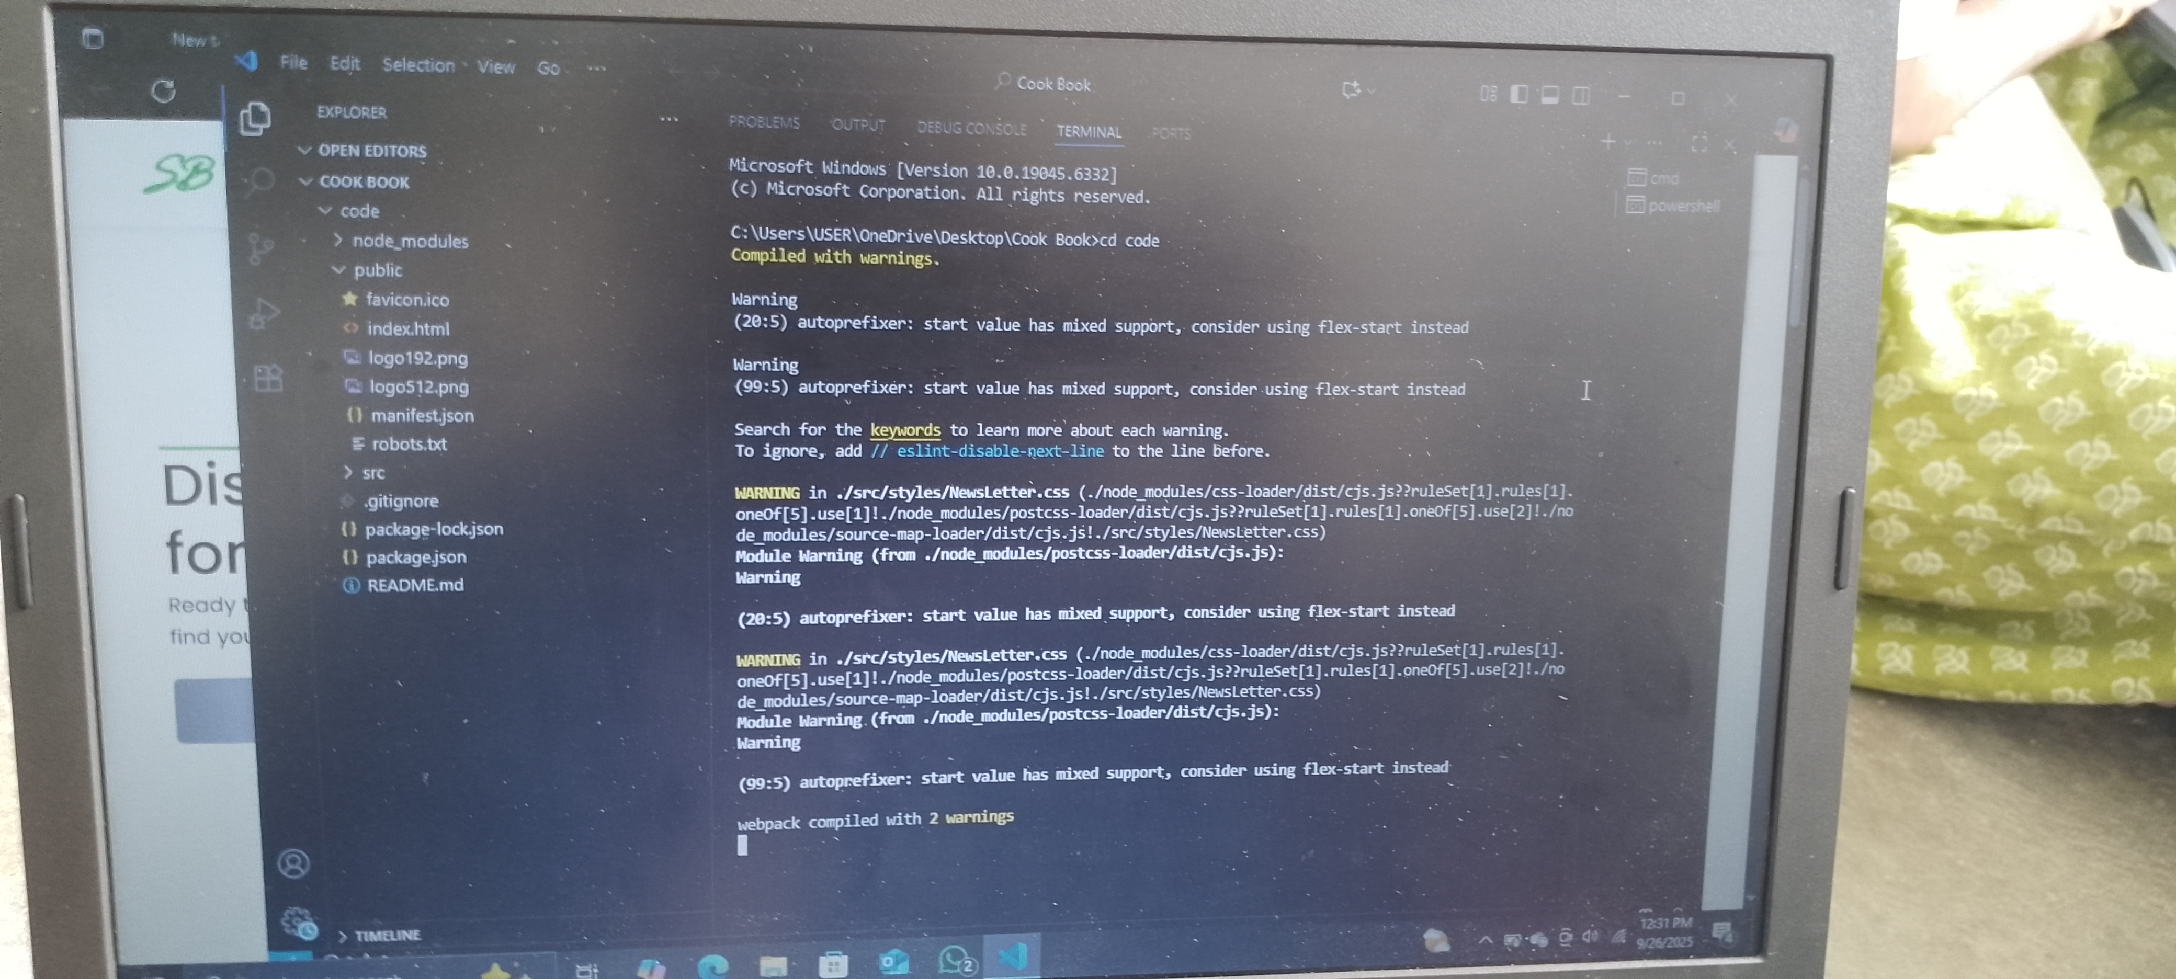

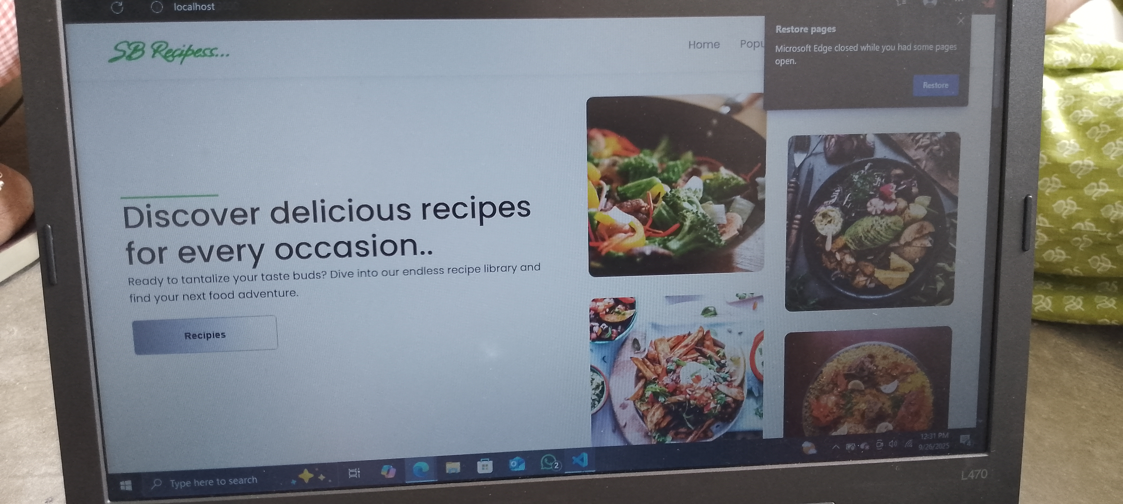

***12. Known Issues***

***13. Future Enhancements***